VEIN TRACING INSTRUCTIONS

**Example good tracings**

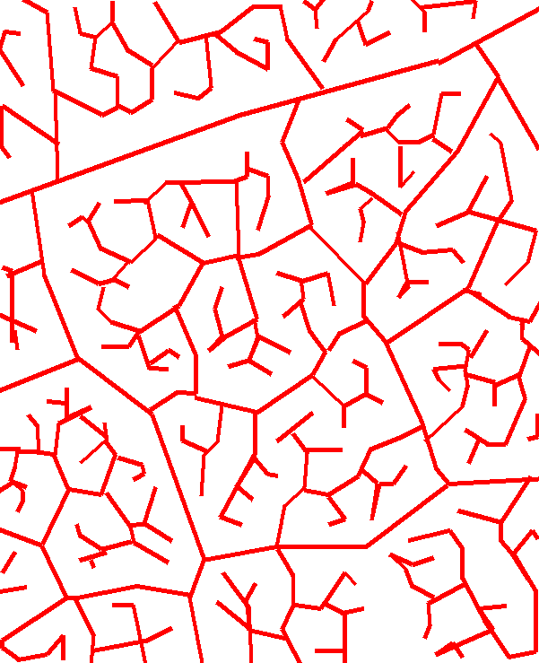 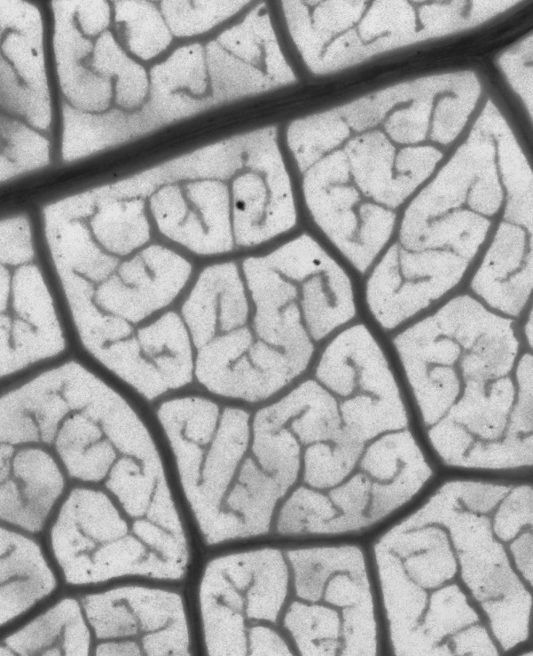

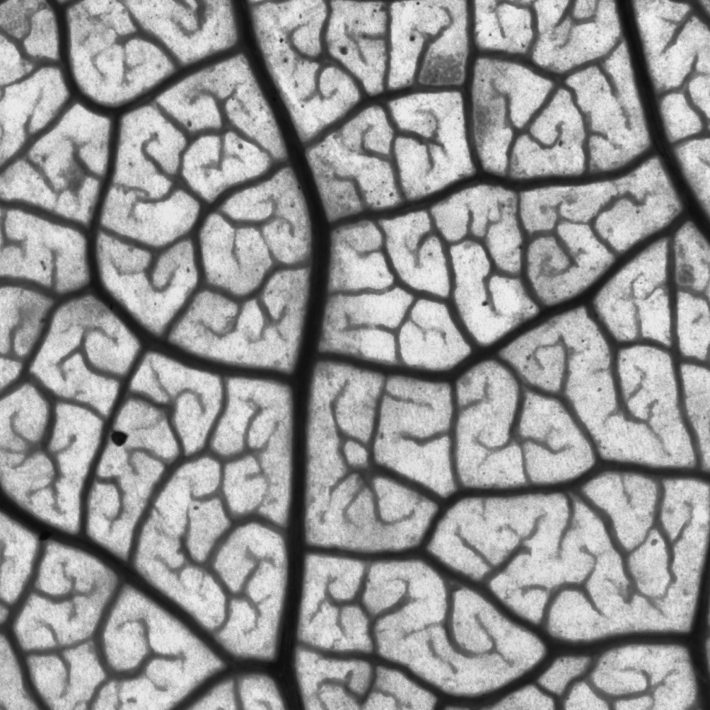 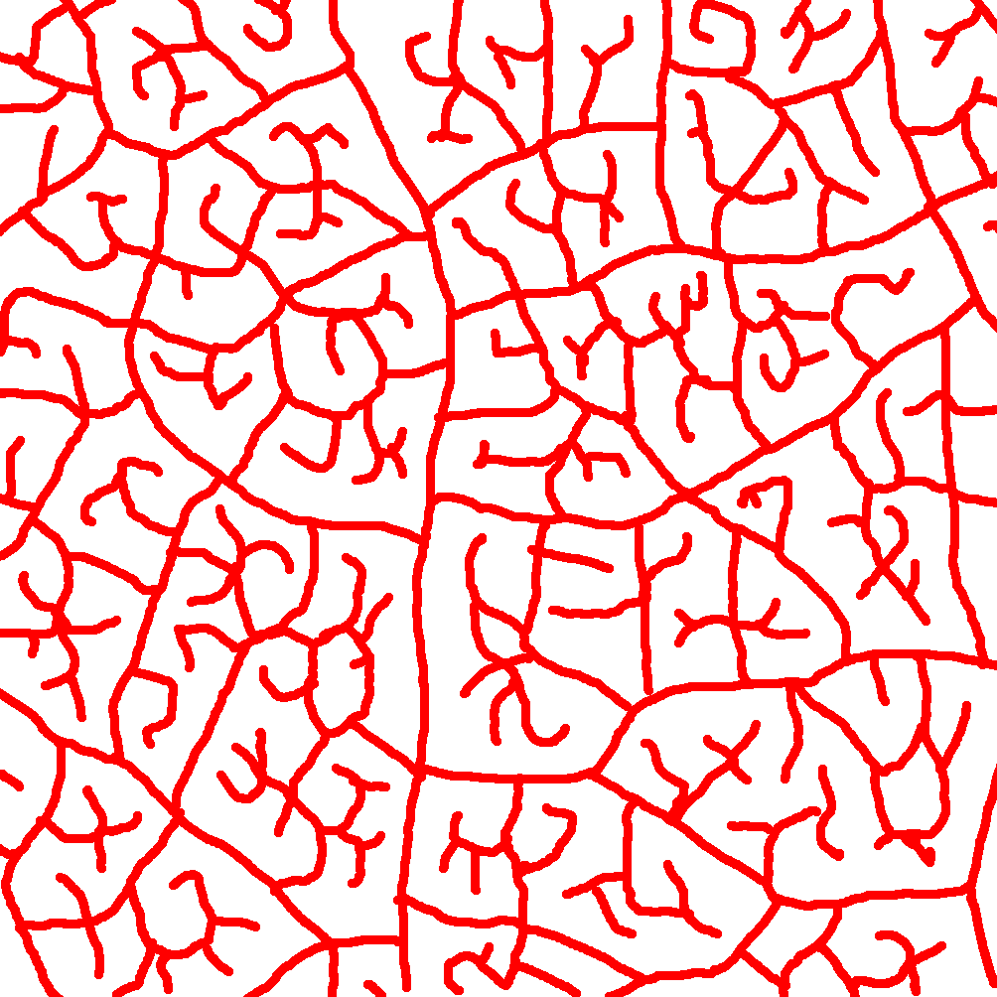

**Things not to trace**

- tears in the leaf. If the tear is small, connect the vein across the tear. If it is large, omit the vein. Ideally the region of interest will not include tears, because you did not include any.

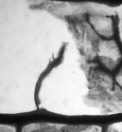 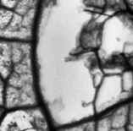

- air bubbles.

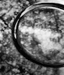 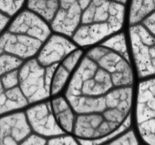

- other blotches. Many artifacts can occur during slide preparation. If it doesn’t look like a vein it isn’t.

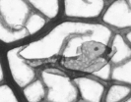 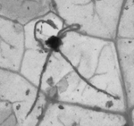

- isolated glands. Disconnected structures, especially dots, are storage structures that are not of interest.

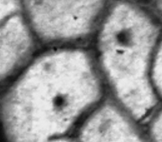 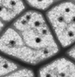

- individual cells. In the below image, the smaller circular structures are individual cells and are not relevant for our analysis.

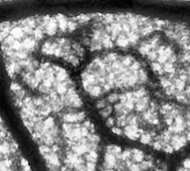 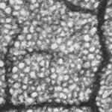

- trichomes and other surface structures. Leaves have hairs and other structures that appear in the chemical staining. They are usually finer and not connected to the rest of the image, or have a conical or star-shaped appearance.

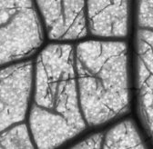 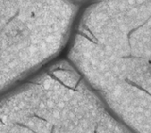 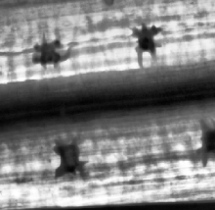

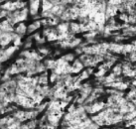 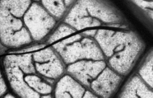

**Odd scenarios**

- inverted images. Sometimes staining will be reversed, with veins lighter than background. Trace the lighter regions of the image instead.

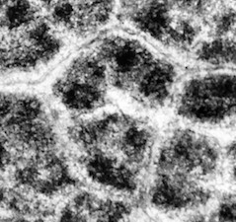

- blurry or unstained images. Some images are hopeless; stop tracing these and make a new slide mount.

